**SSH server-side configurations**

{Examples from Linux Administration Cookbook}

On your remote host (server) go to the /etc/ssh/ directory

$ cd /etc/ssh

Copy your server’s sshd_config file before making any changes

$ sudo cp sshd_config sshd_config.orig

Edit sshd_config file:

$ sudo vi sshd_config

Changing the ssh port from its default 22 requires we run another command

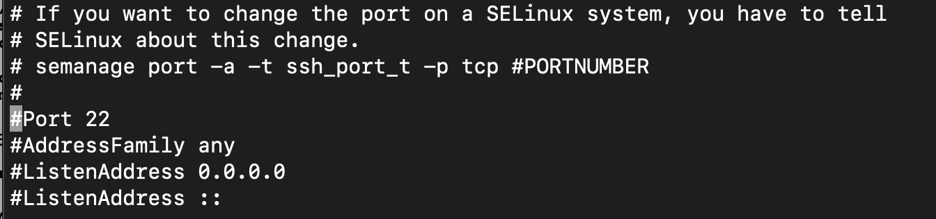

First, figure out which package includes semanage

$ sudo yum whatprovides semanage

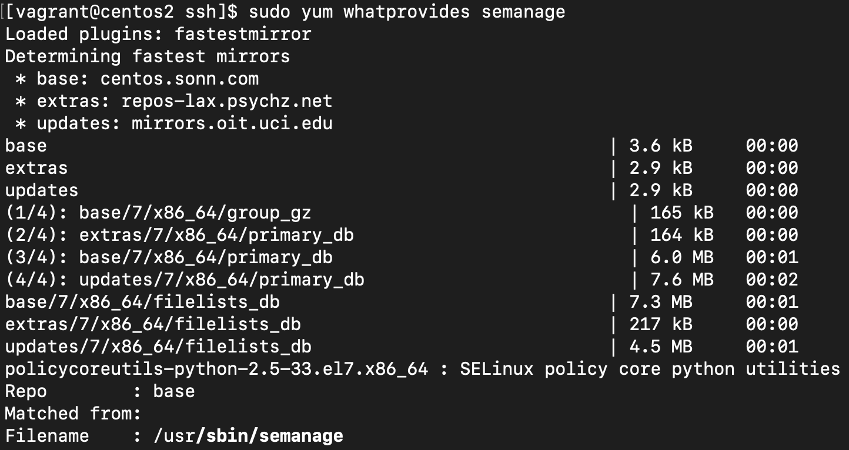

Install the package

$ sudo yum install -y policycoreutils-python

Run the semanage command from the sshd_config

$ sudo semanage port -a -t ssh_port_t -p tcp 2222

Success!

Restart sshd service

$ sudo systemctl restart sshd

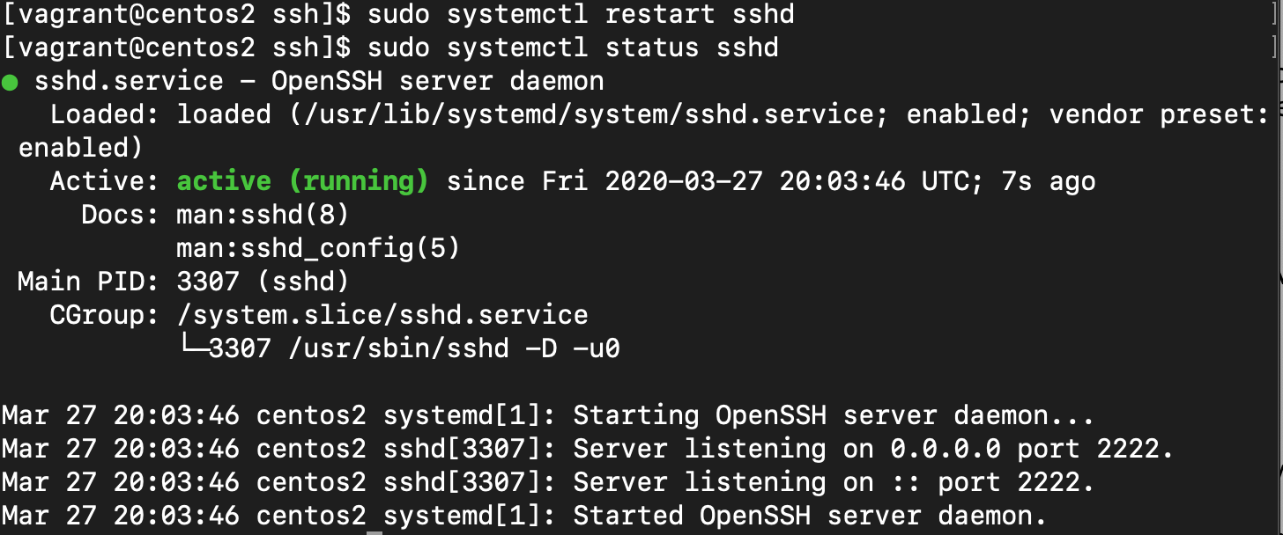

Now, you need to specify port 2222 when ssh’ing into your server



Make ssh listen to only IPv4 and our eth1 address

*by default, ssh listens on all addresses and interfaces as we can see in /etc/ssh/sshd_config